Name: G.R.Nithishkumar (20ucs088)
Program: Usage of YACC Tool
Ex no.: 4 (a)

LEX PROGRAM:

%option noyywrap
%{
#include<stdio.h>
#include "y.tab.h"
%}
%%
[0-9]+ { return number ; }
[a-z]+ { return letter ; }
[\n] { return nl ; }
%%

YACC PROGRAM:

%{
#include<stdio.h>
%}
%token nl number letter
%%
stmt :var nl {
printf("Valid Variable");
}
;
var : letter an
;
an : letter an | number an | letter | number
;
%%
int yyerror()
{
printf("Invalid");
}
int main()
{
printf("Enter the variable:");
yyparse();
return 0;
}

OUTPUT: 4 (a)

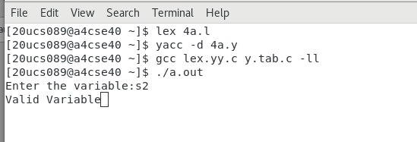

OUTPUT: 4 (b)
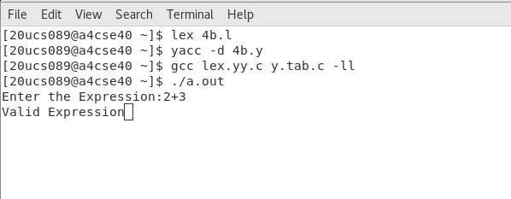

Ex no.: 4 (b)

LEX PROGRAM:

%option noyywrap
%{
#include<stdio.h>
#include "y.tab.h"
%}
%%
[0-9]+ { return number ; }
[\n] { return nl ; }
. { return yytext[0]; }
%%

YACC PROGRAM:

%{
#include<stdio.h>
%}
%token nl number letter
%left '+''-'
%left '*''/'
%%
stmt : E nl {
printf("Valid Expression");
}
;
E : E '+' E | E '-' E |E '*' E | E '/' E | number

%%
int yyerror()
{
printf("Invalid");
}
int main()
{
printf("Enter the Expression:");
yyparse();
return 0;
}

